

**2016S2-DM2294-Game Prototype Project**

**Studio Project 3:  
Phantom Hunter**

**Done By:**

**Chuan Guang Zhe (152104G)**

**Teo Jia Hao (155209G)**

**Zhang Jia Bao, Jason (155212W)**

**Sri Sham Haran S/O R. Raja (155129R)**

**Game Design Document**

**Teacher In charge: Mr Toh Da Jun**

**Mr Johnny Tan**

**Table of Content**

**Introduction** 2

**Genre** 2

**Platform** 2

**Target Audience** 2

**Game Concept** 2

**Story & Setting** 3

**Story** 3

**Look and feel** 3

**Game flow and locations** 3

**Control & Interface** 4

**Game User-Interface (GUI)** 4

**Heads-Up Display (HUD)** 4

**Heads-Up Display (HUD)** 4

**Main Menu** 4

**Loading Screen** 5

**Inventory Overlay** 5

**Enemies** 6

**Combat** 7

**Graphical Theme** 7

# **Introduction**

## **Genre**

Phantom Hunter is a 3D Adventure FPS game set in a Cartoonish Horror universe.

## **Platform**

Phantom Hunter will available on PC.

## **Target Audience**

Phantom Hunter will be targeted at children and teenagers that enjoys casual first person shooter games.

## **Game Concept**

In each level there are wandering ghosts that the player can catch. The player will have limited inventory space to keep the captured ghost. The inventory space can be increased by purchasing upgrades in the shop. Ghosts can be turned into ectoplasm (money) at the main hub, each ghost worth different value. The players can use the ectoplasm to purchase weapons, ammunition and other items. Players can only capture weakened ghosts.

There is a main hub that players can visit to shop for items.  
  
There will be a boss at the last level.

The player will not have HP, but instead will have a “Fear” factor. As fear rises, the player will have decreased vision and if it rises too high the player will faint and be teleported back to the main hub.

# **Story & Setting**

## **Story**

You are dispatched by the National Paranormal Society to hunt down an evil spirit who has been releasing ghosts around the town. Armed with guns that fires ectoplasm and a special vacuum cleaner you set out to complete the task you have been given.

## **Look and feel**

The game is set in modern times. Ghosts will appear cartoonish instead of realistic ghost and the general environment also have cartoonish graphics and outlines to support the theme.

## **Game flow and locations**

**(House)**You start off in a house to gather information on the whereabouts of the evil spirit, upon gathering more information you discover that you have been locked in and the house that is manifested by wandering ghosts. You come to a conclusion that you need to find a way to get out of the house.  
  
**(Town Square)**After you found out that the evil spirit currently resides in town’s cemetery, you exit the house to travel towards the cemetery. Your first stop being the town in which the house is located in. You notice the town is filled with wandering ghosts and the gates to the exit of the town has been locked. You remember there being a key to the gate located within the Town Square.  
  
**(Forest)**Before reaching the cemetery is a thick and dense forest, fogs surrounds you as you approach the cemetery. Dozens of ghosts haunt the forest, tormenting those that pass.

**(Cemetery)**You finally found the evil spirit and face off against the root of the problems.

# **Control & Interface**

## **Game User-Interface (GUI)**

## **Heads-Up Display (HUD)**

During the gameplay, the HUD will consists of:

A Radar – The radar shows the general location of ghosts within the player’s range to give the player a sense of direction. A green dot represents the player, red dot represents wandering ghosts and cyan dot represents ghosts that can be captured. A skull is used to represent [EVIL SKULL].

Current Weapon – A graphical representation of what weapon you have currently selected as well as how much ammunition is left for the selected weapon.

Fear level – Shows the player’s level of fear.

Red Bars (Above Enemies) – Graphical representation of the Hit points of Enemies

## **Heads-Up Display (HUD)**

### **Main Menu**

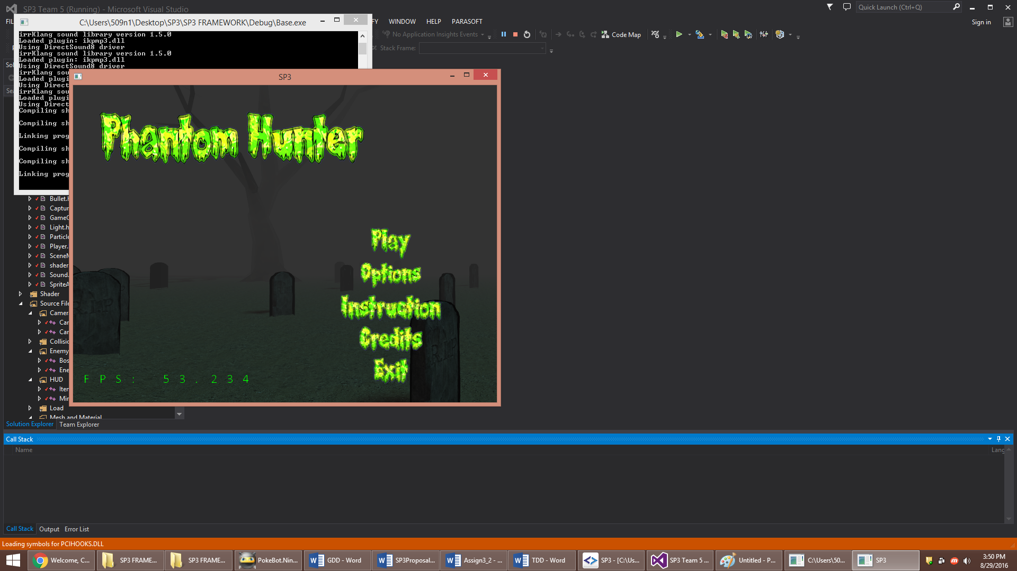

The startup menu will consist of a 2D menu with the following choices:

* “Play” – This starts up the game.
  + Starts the player off into the game.
* “Instructions” – This opens up the instruction screen.
  + Informs the player of how to play the game (Controls & Objectives)
* “Options” – This opens up the options screen.
  + Allows player to adjust settings (Sound, developer view)
* “Credits – This opens up the Credits screen.
  + Shows the player who was in charge of which aspects of the game
* “Quit” – This closes the game and application.

The 2D Menu will overlay a cinematic view of the last level (without the [EVIL SPIRIT])

### **Loading Screen**

Each level has their respective loading screens, this informs the player that the level is being loaded.

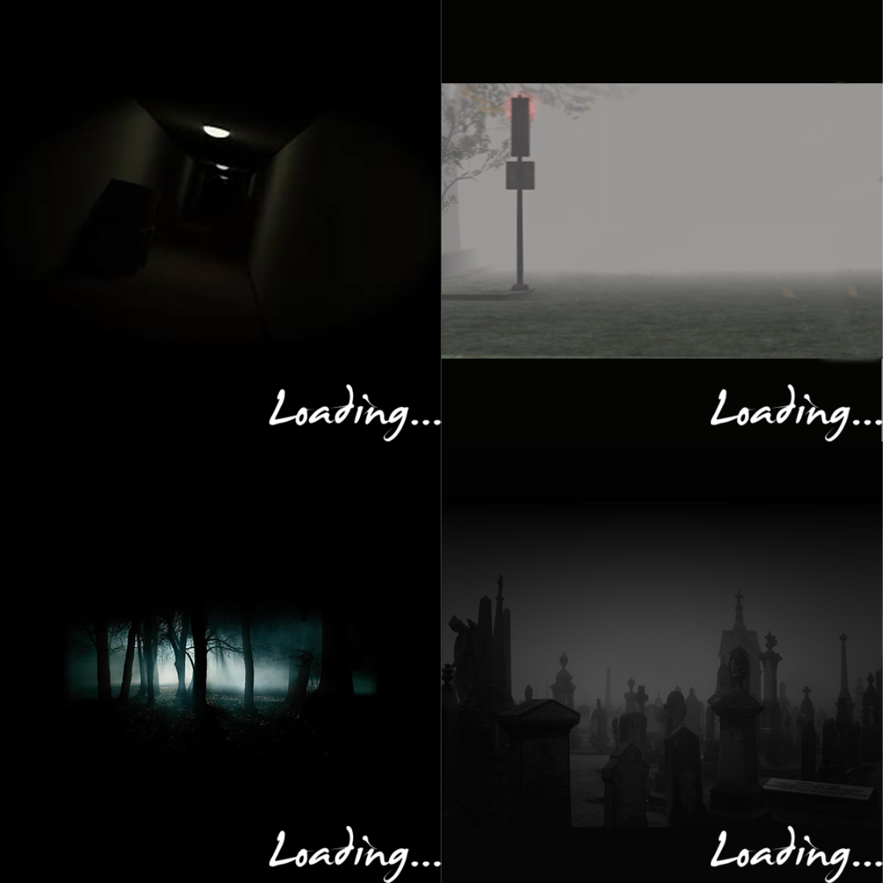

### **Inventory Overlay**

Shows the items & ghosts that the player has.

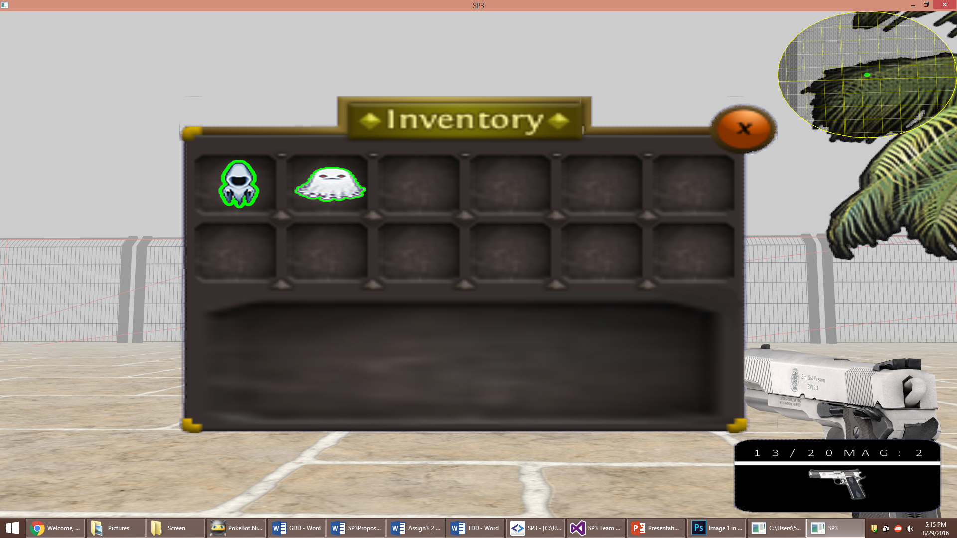

# **Enemies**

Apparition – Medium Hitpoints, attack and speed

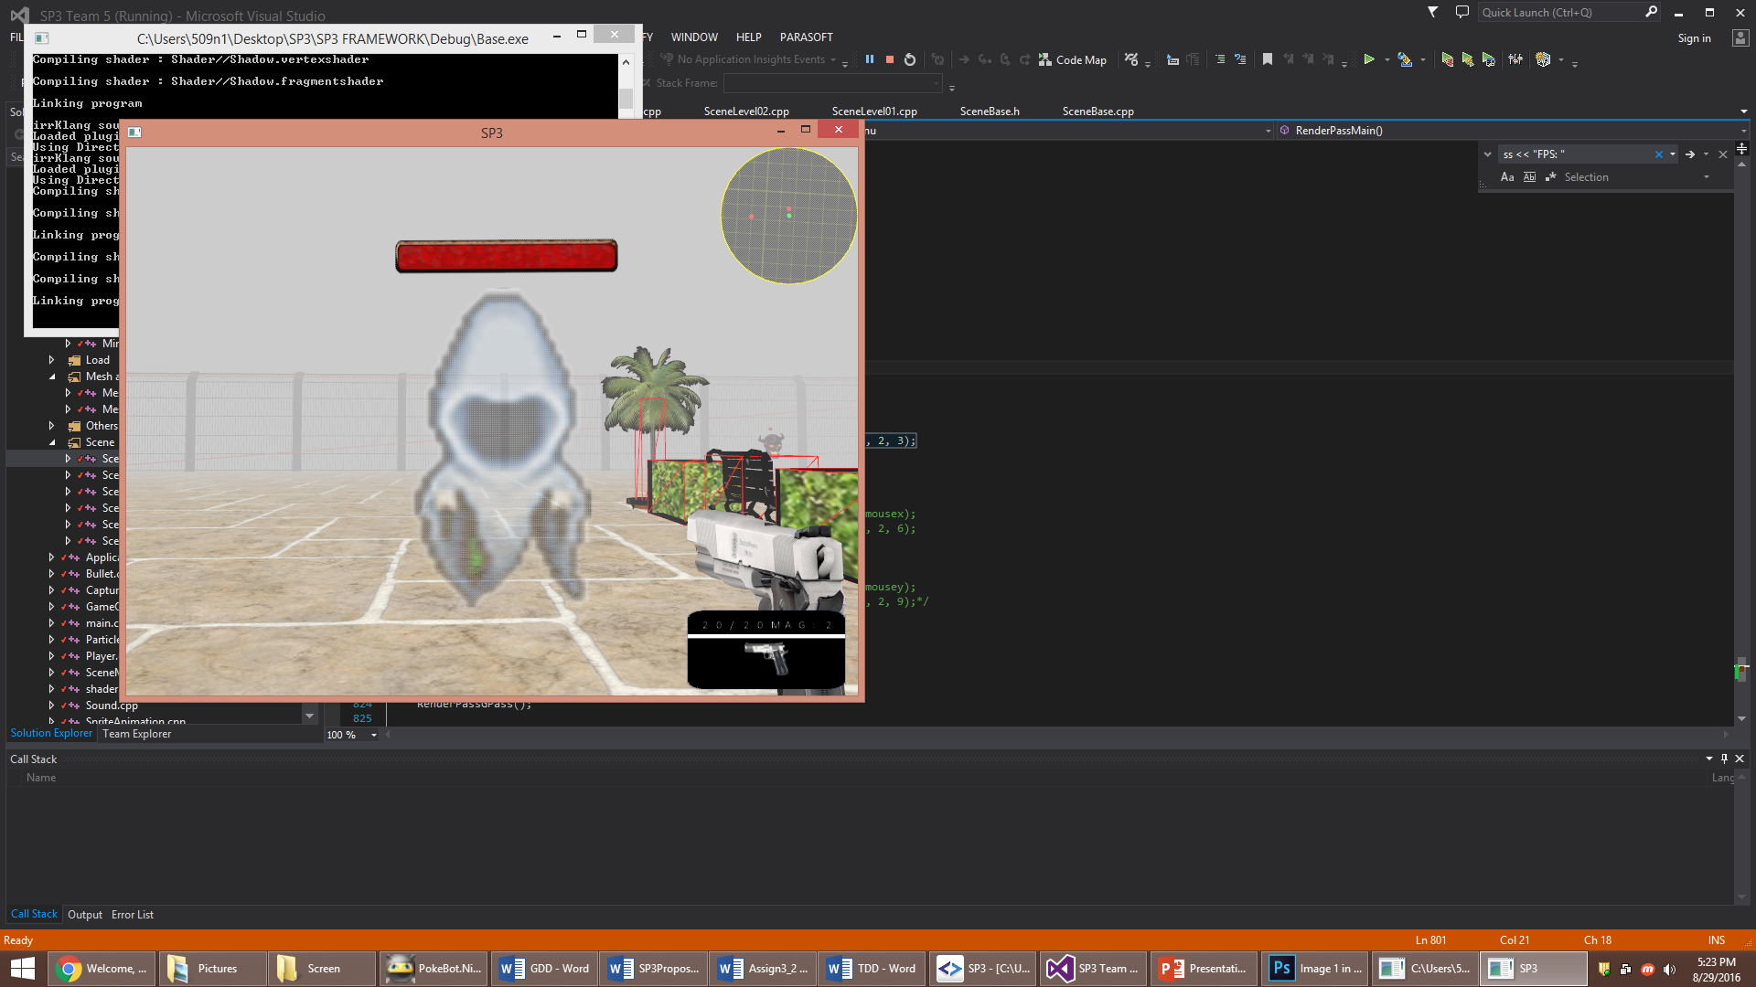

Mini Phantom – High hitpoints, normal speed and attack

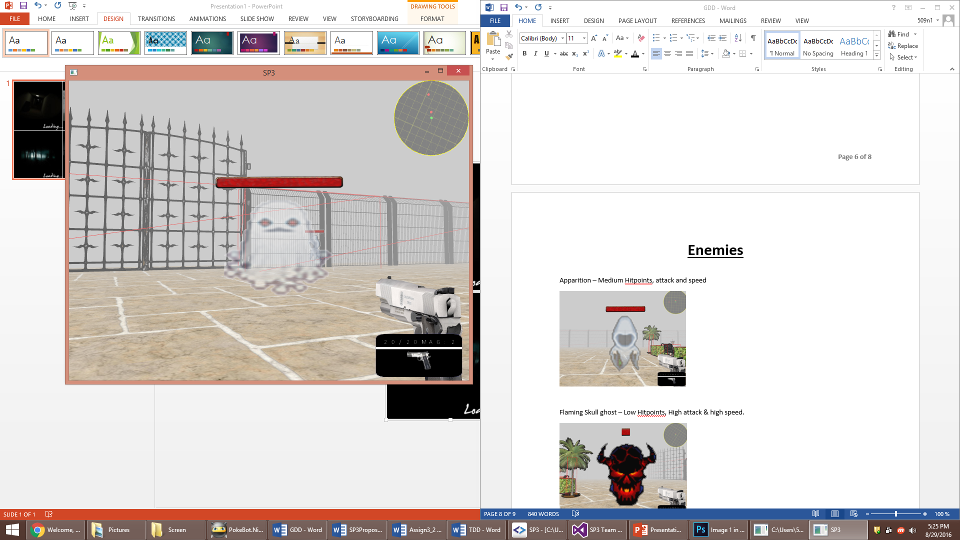

Flaming Skull – Low Hitpoints, High attack & high speed.

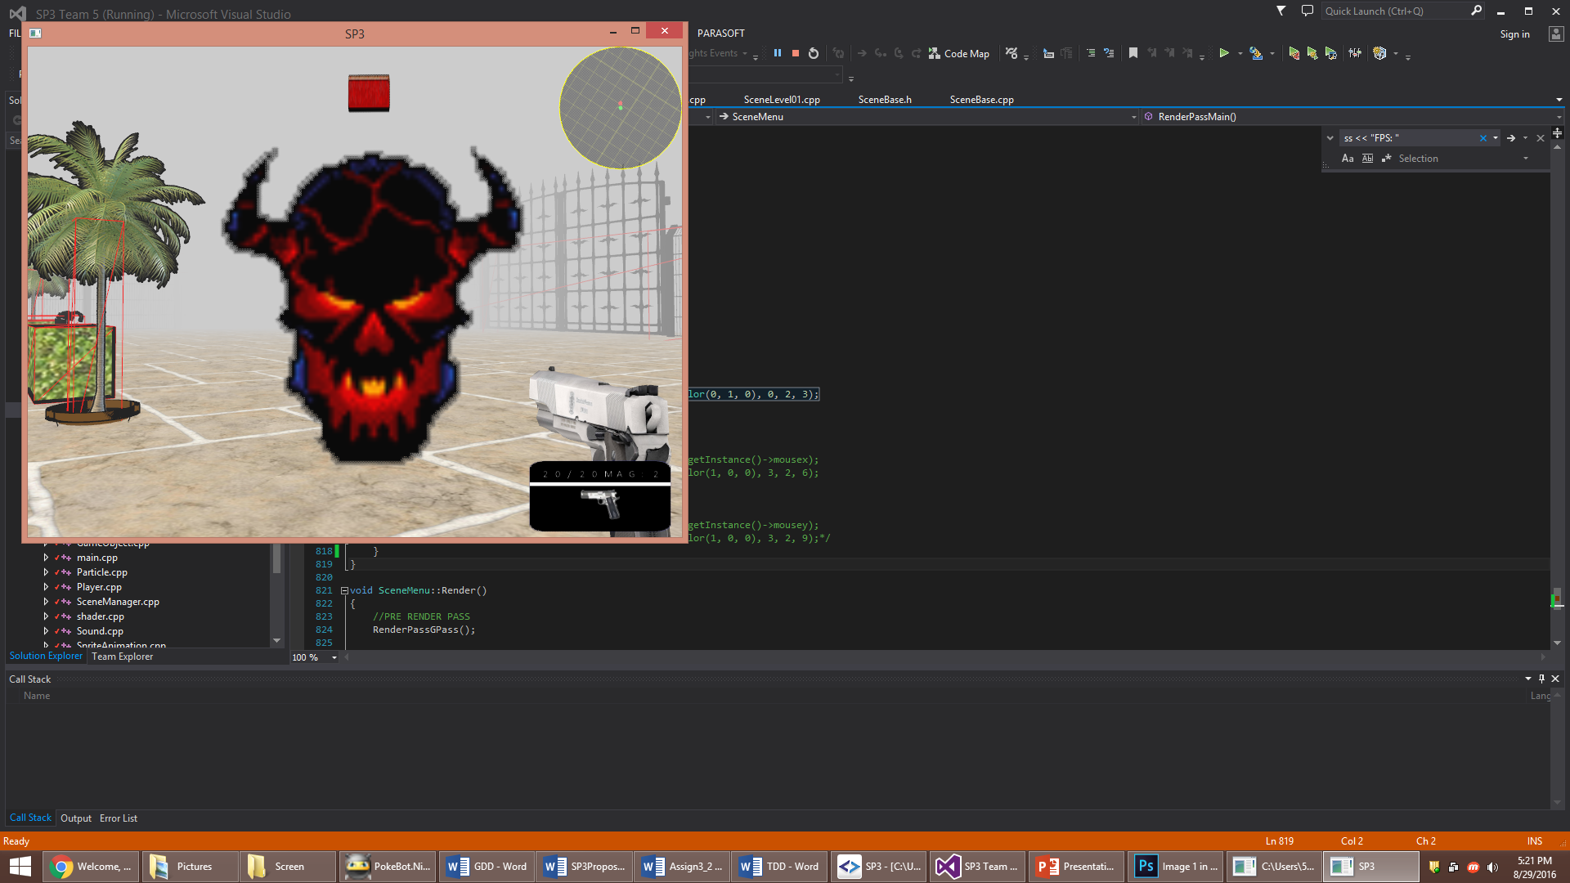

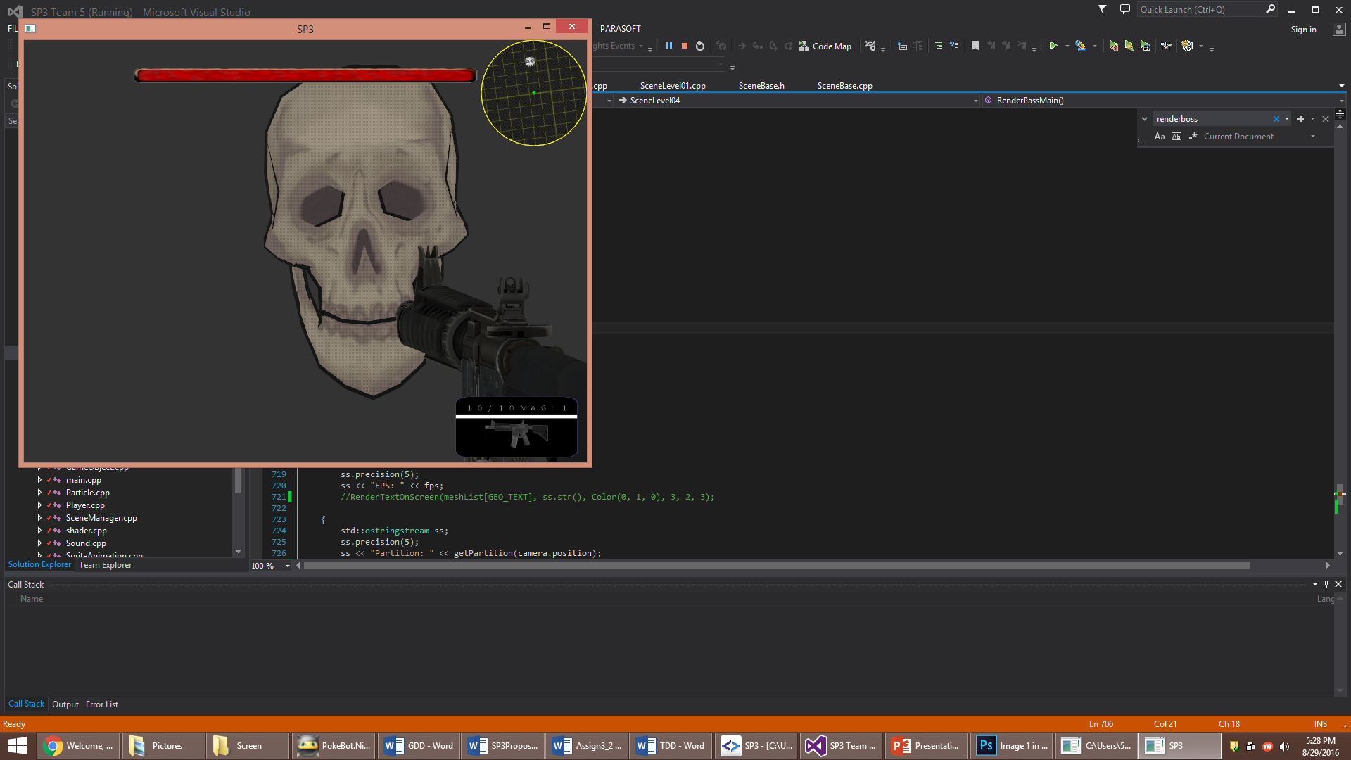

[EVIL SPIRIT] Boss – HIGH HP, SPEED AND ATTACK.

# **Combat**

Player must shoot the enemies to weaken till they can be captured. Only the [EVIL SPIRIT] cannot be captured. Damage can be dealt with guns (Pistol or Rifle) and the ghosts can be captured using a special vacuum.

# **Graphical Theme**

The general graphical theme to the game is a Cartoonish theme while adding elements of horror to the game. This is achieved with cel-shading and environmental effects commonly used in horror movies and games.